National University of Computer and Emerging Sciences



**Laboratory Manual**

***(Operating Systems)***

|  |  |
| --- | --- |
| Semester | Spring 2018 |

Department of Computer Science

FAST-NU, Lahore

**Task 1 (10)**

Create a private shared memory in C/C++. The process then creates a child and waits for the child to write the file’s contents to shared memory. The parent then reads the shared memory and changes the case of each character and removes all integers from the data. The child reads it back and writes the changed data back to the same file. (The file name is passed as command line argument).

**Task 2: (5)**

Again perform task 2 but this time do not create child using fork, create 2 different files from parent and child. For waiting using some variable as flag.

**For Practice only ___**

Merge sort is an algorithm used to sort an integer array of size N. It follows divide and conquer approach. In divide part it divide array in 2 half then again divide both half into further 2 sub half. It repeats this process until each half’s length should not 1. Then it merge each divided part respectively and while merging it sorts array. (Code of merge sort is given with manual)

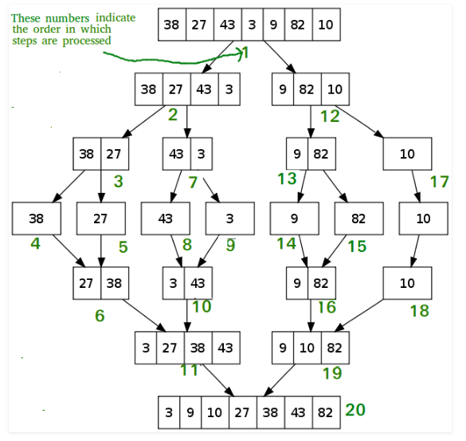

You need to create an array using share memory. Create three variables lower bound (lb), upper bound (ub) and length of array (N) using shared variable. 2 temp arrays of 1/2*N. lenth of these 2 temp arrays (n1 and n2)

Set array in parent and calculate mid of array and set 3 variables according to that then create a child 1 (left side child). First save lb and ub in that child’s local variable then check its array length if greater than 1 then compute again mid and create its child, do that process until child gets 1 element it sets n1 = 1 and set element in temp1 array. Now you are back in your immediate parent (second last child) its run right side child it also set temp2 array and its length. Merge these 2 temp arrays using merge function (given with manual). At the end your top most parent you will make a sorted array.

